Angular 4

Enviromenet Set-up in angular 4:-
we requre following:
    - Nodejs
    - Npm
    - Angular CLI

*angular 4 works on comonent structure

Command to install Command line interface (CLI):-

sudo npm install -g @angular/cli

Command to start a new project:

sudo ng new PROJECT-NAME

Command to compile and run and open in browser:

ng serve --open

To change port --host 0.0.0.0 --port 4500

The following table lists down a few important commands required while working with Angular 4 projects.
Title | Command | Sort form
Component | ng g component new-component | ng g c
Directive | ng g directive new-directive
Pipe | ng g pipe new-pipe
Service | ng g service new-service | Ng g s
Module | ng g module my-module

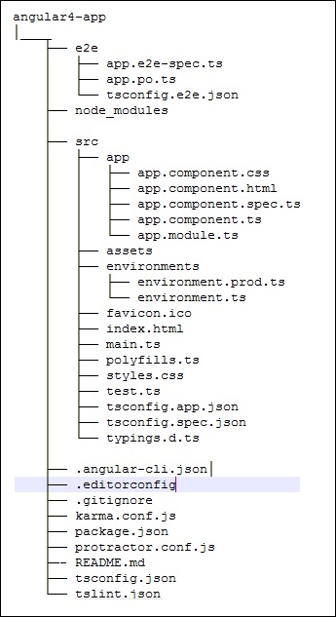
Folder structure:

* Importent files and folders
1. style.css :
global css file for project
2. Assets :
we can save image and js files here
3. Src :
folder where we work on the project
4. app :
folder where we put out components and other files.
5. Component(header) :
component has four files
    - header.component.ts (component)
    - header.component.html (html file for html code)
    - header.component.css (css file for styling)
    - header.component.spec.ts (These are automatically generated files which contain unit tests for source component.)

Component: (src/app/component_name)
Major part of the development with Angular 4 is done in the components. Components are basically classes that interact with the .html file of the component, which gets displayed on the browser.

Component has three major files:-
- HTML file for html code (comonent_name.component.html)
- CSS file for styling (comonent_name.component.css)
- TS file for intract with html (comonent_name.component.ts)

Command to create new component:
sudo ng gc component_name

Importent points about Component:
- App component is parent component.
- Any componenet which added later becomes child component.

Application Flow:-
http://localhost:4200/ => index.html => (<app-root>) main.ts=> (bootstrapModule(AppModule))app.module.ts => (bootstrap: [AppComponent])app.component.ts => (@component)app.component.html

Module:
To define module, we can use the NgModule.
@NgModule and contains an object which has declarations, imports, providers and bootstrap.
Declarations: it is array of component
Imports: array of modules
Providers: services
Bootstrap: initial component for start exicution.

Data Binding in angular:
we use curly braces for Data binding {{}}.this process is called interpolation.
For Loop in Angular:
arrayname = ['element1','element2','element3','element4',]
<div *ngFor=”let i of arrayname”>{{i}}</div>
If condition in Angular:
<span *ngIf=”condition; else elseid”>Condition True</span>
<ng-template #elseid>Condition False</ng-template>

or we can use like below:
<sapn *ngIf=”condition; then ifid else elseid”></span>
<ng-template #ifid>If condition</ng-template>
<ng-template #elseid>Else codition</ng-template>
Pipes:
we use pipe to transform data.
example {{ variable | uppercase }}

List of builtin pipes:
    - Lowercase
    - Uppercase
    - Date
    - Currency
    - Json
    - Percent
    - Decimal
    - Slice

Examples:-

Routing:
Routing means navigating between pages.
To enable routing in angular we have to import RouterModule in app.module.ts file by

import { RouterModule } from '@angular/router';

and then we add refrence into imports array like

imports: [
BrowserModule,
RouterModule.forRoot([
{
path: 'path-name',
component: 'component_class_name'
}
])
],

forRoot is an arry of object which includes path and component.

